**Ideation Phase**

**Define the Problem Statements**

|  |  |
| --- | --- |
| Date | 31 January 2025 |
| Team ID | LTVIP2025TMID32100 |
| Project Name | Citizen AI |
| Maximum Marks | 2 Marks |

**Customer Problem Statement Template:**

Despite the increasing digitalization of governance, **citizens often face challenges in accessing timely and accurate information about government services** or reporting civic issues. Many government portals are **not user-friendly, lack multilingual support**, and require navigating **multiple departments**, which can be confusing and frustrating, especially for rural or non-technical users.

Moreover, there is **no single platform** that allows citizens to **ask queries in natural language, report local issues, and receive AI-powered responses instantly**. This gap in accessibility, responsiveness, and ease of communication leads to **low civic engagement**, **delayed issue resolution**, and **reduced trust in governance** systems.

**Example:**

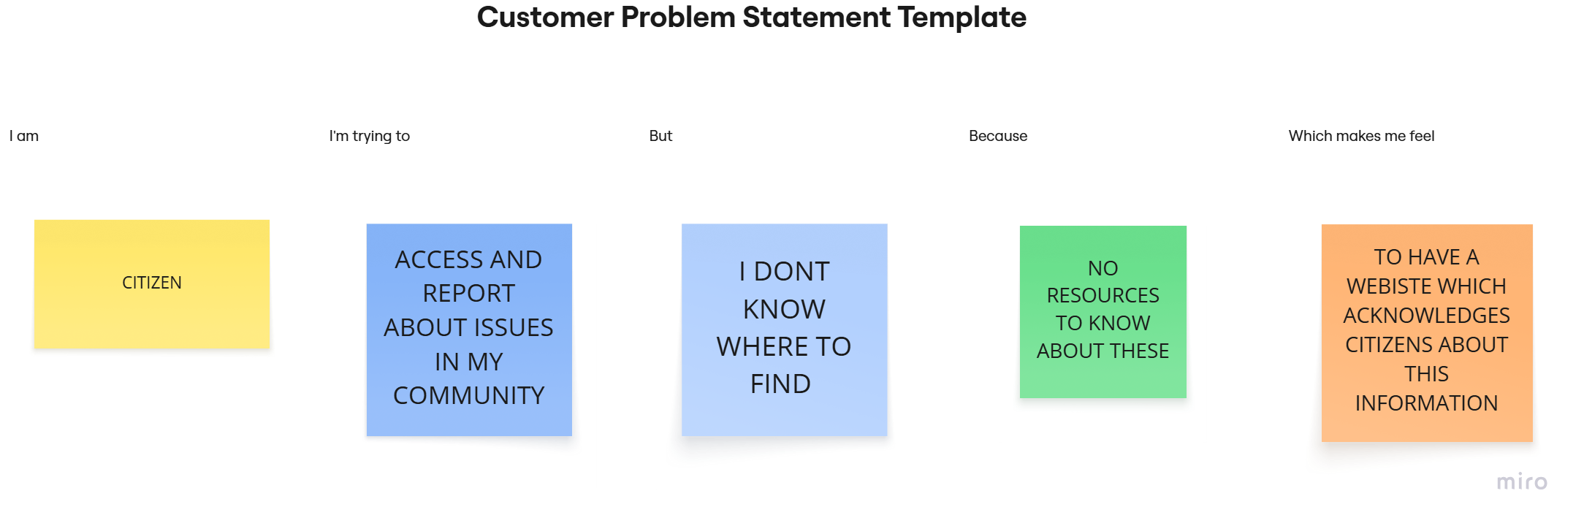

|  |  |  |  |  |  |
| --- | --- | --- | --- | --- | --- |
| **Problem Statement (PS)** | **I am (Customer)** | **I’m trying to** | **But** | **Because** | **Which makes me feel** |
| PS-1 | A working professional | Report a path hole in my way | I don’t know where to report | Government sites are confusing and slow | Frustrated and ignored |
| PS-2 | A student | Get information about available scholarships | The process is too complicated online | Information is spread across websites | Confused and discouraged |
| PS-3 | A retired senior citizen | Learn about pension schemes | I struggle to use mobile apps or websites | They are not user-friendly for elders | Disconnected and anxious |